The *Copy* *Used Units (Copy Program Sources)* (which was derived from the *Used Units* program) program can scan a Delphi program and/or units to construct a list of all units which are used by that program and/or unit. Once scanned, all the required files can be copied to a specified location. In the *Used* Unit tab, specify the file path/name using the *Main Program* text box and browser and then press *Scan*:

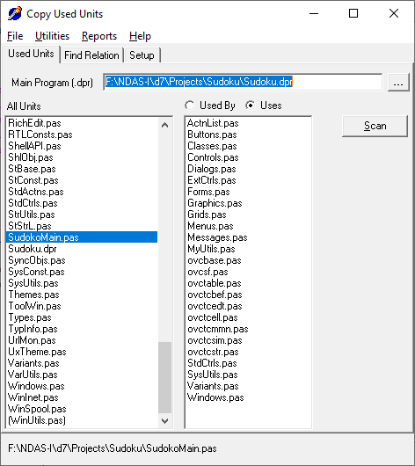

Once scanned, all of the required files can be copied to a root location in the *Utilities* tab with the *Copy Project Sources* menu item.

Once scanned it then becomes possible to find out how two units are connected. i.e., *“Why is this unit getting compiled?”.* This is done on the *Find Relation* page:

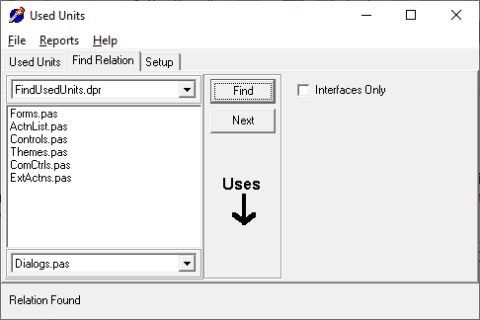

By default, directories associated with the project are scanned as are the .*DOF* paths. Additional paths to search for source code files can be added on the *Setup* Page:

